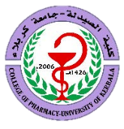

Kerbala Journal of Pharmaceutical Sciences
ISSN: 2221-7207(Print) / ISSN: 3006-7189 (Online)

TITLE: A Focus on Enzyme Modulation and Therapeutic Optimization

Mohammed Ali Hassan^{1*}
¹Department of Pharmacology and Toxicology, College of Pharmacy, University of Karbala, Karbala, Iraq

*Corresponding author
Mohammed Ali Hassan: m.a.h@uokerbala.edu.iq

Received: xx/xx/2024
Accepted: xx/xx/2025
Published: xx/xx/2025

Keywords: word1, word2, ………………………………………………………………..



DOI: 10.62472.xx-xx

Abstract:
Background:

Methodology:

Results:

Conclusion:

العنوان باللغة العربية "تركيز على تعديل الإنزيمات وتحسين العلاج"
محمد علي حسن
الخلاصة:

العينات وطرق العمل:

النتائج:

الاستنتاج:

- Introduction
Beta-thalassemia is an autosomal recessive hereditary condition that affects the β-chain of hemoglobin production. In the Eastern Mediterranean area, including Iraq, the disease is prevalent (Yahya, 1996, Hamamy and Al-Allawi, 2013). The β-thalassemia mutations cause a range of clinical symptoms, starts from thalassemia minor in individuals who are heterozygous for it to β-thalassemia major (β-TM) in those who are homozygous or compound heterozygous , β-TM phenotype is aserious condition linked to several problems with a lifelong need for blood transfusions, stunted growth, diabetes mellitus, liver illness, hypothyroidism, hypoparathyroidism and hypogonadism are among the most common consequences (Galanello and Origa, 2010). With a significantly higher quality of life and fewer problems in developed compared to developing nations, the frequency of these issues vary somewhat throughout β-TM cohorts and are related to the effectiveness of care and follow-up given to these patients (Mikael and Al-Allawi, 2018). Patients should usually start iron chelation treatment when their ferritin levels above 1000 ng/ml or after ten to twenty times blood transfusions (Cappellini et al., 2013). Excessive serum iron can increase the morbidity and death if it is not treated appropriately (Tanaka, 2014).
.
.
.
.
.
.

to investigate the impact of the rs3806596; T>C SNP in the UGT1A3 gene on the therapeutic response to DFX.
- Materials and Methods
  - Study Subjects
The Scientific and Ethical Committee of Karbala University College of Pharmacy examined and approved this cross-sectional study. (Reference number: 2023HU7).
.
.
.
.
.
into evacuated ethylenediaminetetraacetic acid (EDTA) tubes, for other hematological testing and DNA extraction.
  - Genetic Analysis
Following the manufacturer's instructions, the genomic DNA was extracted from the whole blood samples using the Geneaid DNA Extraction/Genomic DNA Purification Prep Mini Kit (Taiwan). .
.
.
.
Electrophoresis was performed on a 2% (w/v) agarose gel to confirm the amplification and identify the PCR products.
- Results
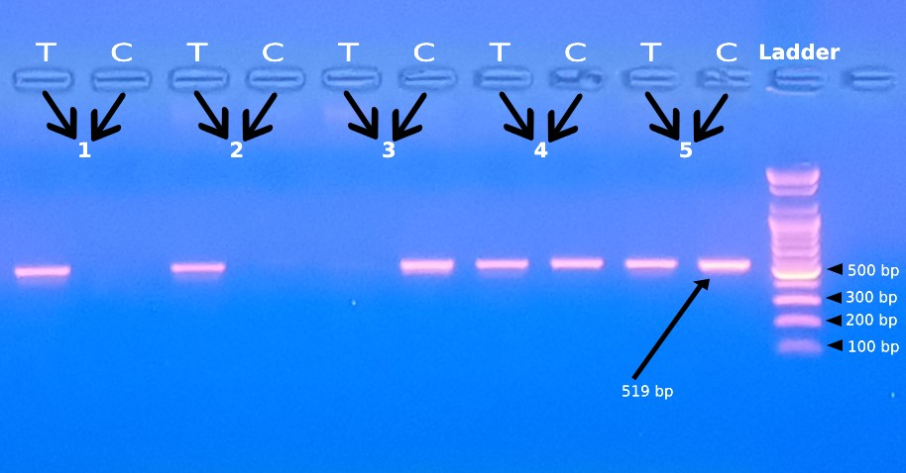
This study included ninty-six Iraqi patients with major β-thalassemia, 42 of whom were male and 54 of whom were female. The rs3806596; T>C SNP was found using allele-specific PCR. Whether T or C alleles were present affected the PCR amplification. The T column of the agarose gel showed a single 519 bp PCR band for the wild type (TT). Two PCR bands, each measuring 519 bp in size were seen in the T and C columns for the heterozygous mutant type (TC). Only the C column showed a single 519 bp PCR band for the homozygous mutant type (CC). Fig.1 illustrates the outcomes.
Figure1: Agarose gel electrophoresis employing allele-specific PCR to detect the rs3806596; T>C SNP. Wild type (TT) is represented by lanes 1 and 2, heterozygous mutant type (TC) by lane 4 and 5 and homozygous mutant type (CC) by lane 3.

The sex distribution and other demographic properties of the study participants are demonstrated in Table1.
According to the patient demographics, the participants' ages ranged from 8 to 39 years old, with around 67% of them being under 19 and just two of them being older than 30. About 82.3% of the participants were urban residency while only 17.7% were rural. Based on marital relativity or paternal consanguinity, the research groups were split into two sex distribution and other demographic characteristics. The rs3806596; T>C SNP genotype distribution revealed that the wild type (TT) allele is making up around 36.5% of individuals, whereas the mutant (CC) allele only makes up 44.8% of the research participants Table2. The patients were divided into three groups according to their genotype. Notably, the analysis reveals no significant differences were observed in the hematological and biochemical parameters Table3.

Table 1: Demographic Characteristics of The Study Subjects
Character |  | Frequency (%)
Sex | Male | 42(43.4)
Sex | Female | 54(56.3)
Age | 8-18 years old | 64 (66.6)
Age | 19-39 years old | 32 (33.3)
Residency | Urban | 79(82.3)
Residency | Rural | 17(17.7)
Marital relativity | Yes | 85(88.5)
Marital relativity | No | 11(11.5)
Blood group | A | 32(33.3)
Blood group | B | 22(22.9)
Blood group | AB | 9(9.4)
Blood group | O | 33(34.4)

- Discussion
This study looked at how the rs3806596; T>C SNP affected the therapeutic response to the DFX medication in TDT patients from Iraq. People with thalassemic syndrome may get iron overload as a result of frequent blood transfusions. Since the body lacks the ability to remove excess iron, an iron-chelation therapy, such as a DFX medication, must be taken (Chaudhary and Pullarkat, 2013, Naderi et al., 2013). .
.
.
.
that it is frequently reversible and/or non-progressive (Díaz-García et al., 2014). In the present study serum creatinine showed normal values.
- Conclusion
There is no significant association between………………………………………………………………………...

- Conflicts of Interest
The authors declare no conflict of interests

References
ADAAY, M. H., AL-ANZY, M. M., AL-SAMARRAI, A.-M. H., AL-TIKRITI, K. A. & AL-SAMARRAI, F. A. 2011. Some Observations on the Occurrence of β-Thalassemia in Mosul. Iraqi J. Med. Sci, 9, 270-274.
AGENT, A. 2021. PRODUCT MONOGRAPH INCLUDING PATIENT MEDICATION INFORMATION.
AL-HAJ, F. 1992. Haemoglobinopathies in Mosul. MSc Thesis University of Mosul Iraq.
AL-SAFAR, S. R. M., AL-ZUBAIDY, H. F. & ALWAIDH, R. H. 2024. An Investigation of the Correlation Between the CNTNAP2 rs7794745 gene Polymorphism and Autism in Children from the Middle Euphrates Area of Iraq. Karbala Journal of Pharmaceutical Sciences, 15, 1-10.
ALLEGRA, S., DE FRANCIA, S., CUSATO, J., ARDUINO, A., MASSANO, D., LONGO, F., PIGA, A. & D’AVOLIO, A. 2017. Deferasirox pharmacogenetic influence on pharmacokinetic, efficacy and toxicity in a cohort of pediatric patients. Pharmacogenomics, 18, 539-554.
AWAD, M. 1999. Homozygous β-thalassemia in Mosul. PhD thesis, Mosul Univ, Iraq.
BABU, T. & PANACHIYIL, G. M. 2022. An Evidence-Based Approach to Treatment with Iron Chelators in Transfusion-Dependent Thalassemia Patients: Present Trends and Future Scenario. Frontiers in Clinical Drug Research-Hematology, 5, 50.

