
Volume x, Issue x, 202x
Original Research

Type the Title of Your Manuscript
(The title is no more than 25 words)

*First Author's Name¹ ,Second Author's Name² , …….
¹The first author Institution (Department / Division, Faculty, University, City, Country)
²The second author Institution (Department / Division, Faculty, University, City, Country)

Correspondence*:
Address: Building, Street name, number, City, Country, Postal Code | e-mail: example@gmail.com

DOI: 10.63540
Received: Jan xx, 202x Accepted: Jan xx, 202x Published: Jan xx, 202x

Abstract
The abstract must be self-contained and should not include any citations. It should succinctly convey the manuscript's objective, methodology, key findings, and overall significance. The content should be presented in a clear, accessible manner without excessive technical detail, ensuring that a well-informed reader can grasp the paper’s contribution. The abstract page should feature the manuscript title only excluding the author’s name or any identifying information. The abstract length should range between 150 to 250 words.
Keywords: Authors are encouraged to include 3 to 6 keywords relevant to the manuscript.
JEL Classification: Please provide 1 to 3 appropriate Journal of Economic Literature (JEL) classification codes. A complete list is available at https://www.aeaweb.org/jel/guide/jel.php.
- Introduction
The Introduction should provide a concise and clear overview of the research background, outline the core research problems, and state the primary objectives of the study. It should also highlight the anticipated value or impact of the research findings. Authors are encouraged to reference relevant prior studies to establish the context. Ideally, the final sentence of the introduction should clearly articulate the main aim of the study.
- Literature Review and (Hypothesis Development if possible)
The Literature Review should present relevant theoretical frameworks and prior empirical studies that support the development of the study’s hypotheses.
- Data and Methodology

The Data and Methodology section should detail the types of data used, the period of analysis, and the data sources. It must also thoroughly describe the research methodology, including the research design, target population, sample size and sampling techniques, research procedures, variables or parameters observed, and analytical methods employed. This section should be presented in a descriptive narrative that clearly outlines how the study was conducted.
- Results and Discussion
The Findings and Discussion section should provide a comprehensive explanation of the primary research outcomes. Authors are encouraged to emphasize and discuss the most critical findings in the text rather than presenting results solely through tables. The narrative should interpret these findings in the context of the study’s objectives and relevant literature.
4.1. Sub-Chapter of Result and Discussion
Authors are expected to analyze and interpret their findings while drawing connections to existing literature, supported by scholarly discussion and well-founded arguments. The discussion should remain aligned with the research objectives stated in the Introduction. To enhance clarity and support the narrative, authors may incorporate tables or figures within the Results and Discussion section.
Table Format
Table titles should be placed above each table and formatted as “Table X” (e.g., Table 1), using single spacing and regular (non-bold) font. Tables must be numbered sequentially based on their first appearance in the text and follow an open layout format, displaying only horizontal lines. A maximum of three tables is allowed. Each title should clearly address “what,” “where,” and “when.” If a table is adapted from another source, the citation must be provided beneath the table in a 7pt font. Tables should not be split across pages, must fit within the page margins, and should not be truncated. Extensive tables (exceeding two-column width) should be placed either at the beginning or the end of the page, as illustrated in Table 2.

Table 1. Title of Tables is written above the table
 | Revenues | Exposure
Risk | ## | ##
Return | ## | ##
Source: source is placed below the table (optional)

Table 2. The title is written above the table
Variables | Variables |  |  |  | Variables
Variables | First |  | Second |  | Variables
Variables | n | % | n | % | Variables
Variables |  |  |  |  | ##
Variable | ## | ## | ## | ## | ##
Variable | ## | ## | ## | ##* | ##
Variables
Variable | ## | ##* | ## | ## | ##
Variable | ## | ## | ## | ##
* Additional Statement

Format Images and Graphics
Captions or titles for figures and graphs should be centered and placed beneath the corresponding image. Each figure must be numbered sequentially in the order it appears in the text, using the format Figure X (e.g., Figure 1), with regular spacing and without bold formatting. Figures should follow an open layout style and use only horizontal lines where applicable. A maximum of three figures is permitted, and each must fit within the page margins. If a figure is reproduced or adapted from another source, the citation must be clearly provided below the image.
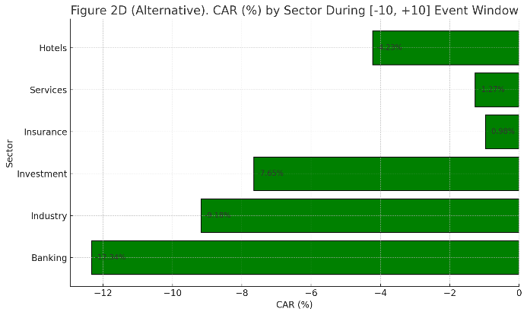

Source: author's name (year) 7 Arial font pt.
Figure 1. The title is written below the image (centred)

- Conclusion
Conclusions and Recommendations should directly address the research objectives. Conclusions must be comprehensive, clearly summarizing the key findings while offering meaningful insights. Authors are encouraged to articulate new contributions derived from the study and provide practical or theoretical recommendations based on the results. These recommendations should be aligned with the research aims and supported by logical reasoning. Additionally, this section may include a discussion of the study’s limitations and offer constructive suggestions for future research directions.
Conflict of Interest
Please declare whether or not the submitted work was carried out with a conflict of interest. If yes, please state any personal, professional or financial relationships that could potentially be construed as a conflict of interest. If no, please add "The authors declare no conflict of interest".

Funding
Please add funding information here, e.g., this research was funded by NAME OF FUNDER, grant number XX. If there is no funding, write” The authors have received no funding”.

Acknowledgment
The authors wish to thank A, B, C.

References
Each manuscript must include a reference list that contains only the sources cited within the text. Authors are strongly encouraged to use reference management tools such as Mendeley, EndNote, or Zotero to ensure consistency and accuracy. Every reference entry must include complete bibliographic information to allow for clear and unambiguous identification. The journal adheres to the APA (American Psychological Association) citation style, using the author–date referencing system. Additionally, authors are required to include the DOI (Digital Object Identifier) for each reference, whenever available, to facilitate access and verification of cited sources.
Example:
Fama, E. F., & French, K. R. (1993). Common risk factors in the returns on stocks and bonds. Journal of Financial Economics, 33(1), 3–56. https://doi.org/10.1016/0304-405X(93)90023-5
Porter, M. E. (1996). What is strategy? Harvard Business Review, 74(6), 61–78. https://doi.org/10.5465/AMBPP.1996.4978745
Chen, H., Daneshmand, M., & Xu, Y. (2020). Artificial intelligence applications in financial markets: A review. Expert Systems with Applications, 158, 113558. https://doi.org/10.1016/j.eswa.2020.113558

